Assignment 3:

Question 1:

AIM:
To write a code that reads movie and displays the required data.

Code:
"""
Assignment 3 Question 1 done by Vansh Aggarwal
Date: 18/6/24
Time of start: 11:30

"""
import pickle as p

#create file

def create_file():
f = open("movie.dat", "wb")
f.close()
print("File Created")

while True:
print ("Do you want to erase the file or continue with the previous file: ")
opt2 = int(input ("Enter 1 for yes and 2 for no: "))
if opt2 == 1:
create_file()
break
elif opt2 == 2:
print ("File Retained.")
break
else:
print ("Try again.")

# Main Code:

def addmovie():
rating = 1000
while rating<0 or rating > 10:
rating = int(input("Enter the movie rating: "))

movie = input ("Enter movie name: ")
language = input ("Enter movie language: ")

fout = open("movie.dat", "ab")
temp_input = [rating, movie, language]
p.dump(temp_input, fout)
fout.close()

def readmovie():
data = []
try:
with open("movie.dat", "rb") as fout:
while True:
data_1 = p.load(fout)
data.append(data_1)
except EOFError:
print("End of file reached in 'movie.dat'.")
finally:
fout.close()
return(data)

def bestrated():
movie = ""
rating = 0
data = readmovie()
for i in data:
if i[0]>rating:
movie = i
rating = i[0]
return(movie)

#Main Loop:

while True:
print ('''
Options:
1) Write the Movie to a binary file.
2) Read the Movie from a binary file and display the records.
3) Search the record of the Movie which has the highest rating. ''' )

opt1 = int(input("Enter the option to execute: "))

if opt1==1:
addmovie()

if opt1 ==2:
data = readmovie()
for i in data:
print (i)

if opt1 ==3:
mov = bestrated()
print (mov)

Sample Output:
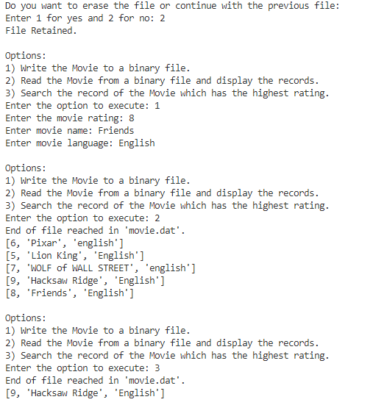

Question 2:

AIM:
Write menu driven python program to create a binary file (Product.dat) storing the
Dictionary Product and perform given operations.

Code:
"""
Assignment 3 Question 2 done by Vansh Aggarwal
Date: 21/6/24
Time of start: 11:29

"""
import pickle as p
import os

#create file

def create_file():
f = open("product.dat", "wb")
f.close()
print("File Created")

while True:
print ("Do you want to erase the file or continue with the previous file: ")
opt2 = int(input ("Enter 1 for yes and 2 for no: "))
if opt2 == 1:
create_file()
break
elif opt2 == 2:
print ("File Retained.")
break
else:
print ("Try again.")

# Main Code:

def addproduct():
fout = open("product.dat", "ab")
pid = int(input("Enter product ID:"))
pname = input("Enter Product Name: ")
qty = int(input("Enter Quantity of the product: "))
price = float(input("Enter Price of product: "))
product = {"pid":pid,"pname":pname, "qty":qty, "price":price}
p.dump(product, fout)
fout.close()

def readproduct():
data = []
try:
with open("product.dat", "rb") as fout:
while True:
data_1 = p.load(fout)
data.append(data_1)
except EOFError:
print()
finally:
fout.close()
return(data)

def searchproduct(search_string):
data = readproduct()
for i in data:
if i["pname"] == search_string:
return(i)
else:
return("No such product found. ")

def update_price(search_string):
fout = open("product1.dat", "wb")
fout.close()
################################
fout = open("product1.dat", "ab")
data = readproduct()
for i in data:
if i['pname'] != search_string:
p.dump(i,fout)
elif i['pname'] == search_string:
new_price = float(input("Enter the new price: "))
i["price"] = new_price
p.dump(i,fout)

fout.close()

os.remove("product.dat")
os.rename("product1.dat", "product.dat")
print ("changes made")

def del_product(search_string):
fout = open("product1.dat", "wb")
fout.close()
################################
fout = open("product1.dat", "ab")
product = searchproduct(search_string)
data = readproduct()
for i in data:
if i != product:
p.dump(i,fout)

fout.close()

os.remove("product.dat")
os.rename("product1.dat", "product.dat")

print ("Lines deleted")

def move_product(search_string):
fout = open("product2.dat", "wb")
fout.close()
################################
fout = open("product2.dat", "ab")
#################################
fin = open("product1.dat", "wb")
fin.close()
################################
fin = open("product1.dat", "ab")
product = searchproduct(search_string)
data = readproduct()
for i in data:
if i == product:
p.dump(i,fout)

if i != product:
p.dump(i, fin)

fin.close()
fout.close()
os.remove("product.dat")
os.rename("product1.dat", "product.dat")

print ("Lines moved. ")

#Main Loop:

while True:
print ('''
Options:
1) Add more data
2) Display All
3) Search for a product by name
4) Update the product price
5) Delete the product
6) Move certain products (by name) to a separate file.''' )

opt1 = int(input("Enter the option to execute: "))

if opt1==1:
addproduct()

elif opt1 ==2:
data = readproduct()
for i in data:
print (i)

elif opt1 ==3:
search_string= input("Enter the product to search: ")
required_p = searchproduct(search_string)
print (required_p)

elif opt1 == 4:
search_string= input("Enter the product: ")
update_price(search_string)

elif opt1 == 5:
search_string= input("Enter the product: ")
del_product(search_string)

elif opt1 == 6:
n = int(input("Enter the number of items to move: "))
for i in range (n):
search_string= input("Enter the product: ")
move_product(search_string)

elif opt1 ==7:
break

Sample Output:

PS D:\Vansh Aggarwal-11b\Vansh_12B> & C:/Python310/python.exe "d:/Vansh Aggarwal-11b/Vansh_12B/Assignment 3/products.py"
Do you want to erase the file or continue with the previous file:
Enter 1 for yes and 2 for no: 2
File Retained.

Options:
1) Add more data
2) Display All
3) Search for a product by name
4) Update the product price
5) Delete the product
6) Move certain products (by name) to a separate file.
Enter the option to execute: 1
Enter product ID:2323
Enter Product Name: testpaper
Enter Quantity of the product: 123
Enter Price of product: 7878

Options:
1) Add more data
2) Display All
3) Search for a product by name
4) Update the product price
5) Delete the product
6) Move certain products (by name) to a separate file.
Enter the option to execute: 2

{'pid': 1829382, 'pname': 'books', 'qty': 128, 'price': 90.0}
{'pid': 83948, 'pname': 'chauhan', 'qty': 1902, 'price': 29.0}
{'pid': 2, 'pname': 'no', 'qty': 192, 'price': 48903.0}
{'pid': 2323, 'pname': 'testpaper', 'qty': 123, 'price': 7878.0}

Options:
1) Add more data
2) Display All
3) Search for a product by name
4) Update the product price
5) Delete the product
6) Move certain products (by name) to a separate file.
Enter the option to execute: 3
Enter the product to search: no

{'pid': 2, 'pname': 'no', 'qty': 192, 'price': 48903.0}

Options:
1) Add more data
2) Display All
3) Search for a product by name
4) Update the product price
5) Delete the product
6) Move certain products (by name) to a separate file.
Enter the option to execute: 4
Enter the product: books

Enter the new price: 100
changes made

Options:
1) Add more data
2) Display All
3) Search for a product by name
4) Update the product price
5) Delete the product
6) Move certain products (by name) to a separate file.
Enter the option to execute: 2

{'pid': 1829382, 'pname': 'books', 'qty': 128, 'price': 100.0}
{'pid': 83948, 'pname': 'chauhan', 'qty': 1902, 'price': 29.0}
{'pid': 2, 'pname': 'no', 'qty': 192, 'price': 48903.0}
{'pid': 2323, 'pname': 'testpaper', 'qty': 123, 'price': 7878.0}

Options:
1) Add more data
2) Display All
3) Search for a product by name
4) Update the product price
5) Delete the product
6) Move certain products (by name) to a separate file.
Enter the option to execute: 5
Enter the product: no

Lines deleted

Options:
1) Add more data
2) Display All
3) Search for a product by name
4) Update the product price
5) Delete the product
6) Move certain products (by name) to a separate file.
Enter the option to execute: 2

{'pid': 1829382, 'pname': 'books', 'qty': 128, 'price': 100.0}
{'pid': 83948, 'pname': 'chauhan', 'qty': 1902, 'price': 29.0}
{'pid': 2323, 'pname': 'testpaper', 'qty': 123, 'price': 7878.0}

Options:
1) Add more data
2) Display All
3) Search for a product by name
4) Update the product price
5) Delete the product
6) Move certain products (by name) to a separate file.
Enter the option to execute: 6
Enter the number of items to move: 1
Enter the product: chauhan

Lines moved.

Options:
1) Add more data
2) Display All
3) Search for a product by name
4) Update the product price
5) Delete the product
6) Move certain products (by name) to a separate file.
Enter the option to execute: 2

{'pid': 1829382, 'pname': 'books', 'qty': 128, 'price': 100.0}
{'pid': 2323, 'pname': 'testpaper', 'qty': 123, 'price': 7878.0}

Question 3:

AIM:
To write a code that reads movie and displays the required data.

Code:
"""
Assignment 3 Question 3 done by Vansh Aggarwal
Date: 3/7/24
Time of start: 12:11

"""
import csv as c
import os

#create file

def create_file():
f = open("EMP.csv", "w")
f.close()
f = open ("EMP.csv", "a")
fout = c.writer(f)
header = ["EName", "EmpID", "Salary", "Department"]
fout.writerow(header)
f.close()
print("File Created")

while True:
print ("Do you want to erase the file or continue with the previous file: ")
opt2 = int(input ("Enter 1 for yes and 2 for no: "))
if opt2 == 1:
create_file()
break
elif opt2 == 2:
print ("File Retained.")
break
else:
print ("Try again.")

# Main Code:

def add_row():
fout = open ("EMP.csv", "a+")
EName = input("Enter the employee name: ")
EmpID = int(input("Enter the employee id: "))
Salary = float(input("Enter the salary: "))
Department = input ("Enter the department: ")
temp = [EName, EmpID, Salary, Department]
finput = c.writer(fout)
finput.writerow(temp)
fout.close()

def return_data():
fout = open ("EMP.csv", "r")
csvreader = c.reader(fout)
header = []
header = next(csvreader)
rows = []
for row in csvreader:
if row != []:
rows.append(row)
fout.close()

return (header,rows)

def Search(string):
header,rows= return_data()
for i in rows:
if i [0]==string:
return(i)

else:
return("No Record Found.")

def dept(string):
header,rows = return_data()
dept = []
for i in rows:
if i[3] == string:
dept.append(i)
return(dept)

def sort_():
header,rows = return_data()
for i in range (len(rows)):
for j in range (len(rows)):
if rows[i][2]<= rows[j][2]:
rows[i], rows[j] = rows[j], rows[i]
return (rows)

# Main Loop

while True:
print ('''
Options:
1) Add more rows
2) Display All
3) Search for a particular employee
4) Display the list of all employees working in a particular department given by user.
5) Sort the employee as per their salary and display.''' )

opt1 = int(input("Enter the option to execute: "))

if opt1==1:
add_row()

elif opt1 ==2:
header, data = return_data()
print (f'{header[0]:30}{header[1]:30}{header[2]:30}{header[3]:30}')
for i in data:
print(f'{i[0]:30}{i[1]:30}{i[2]:30}{i[3]:30}')

elif opt1 ==3:
temp_search = input ("Enter the employee name")
employee_found = Search(temp_search)
if employee_found != "No Record Found.":
print(f'{employee_found[0]:30}{employee_found[1]:30}{employee_found[2]:30}{employee_found[3]:30}')

else:
print (employee_found)

elif opt1 ==4:
temp_search = input ("Enter the department: ")
data = dept(temp_search)
if len(data)>1:
for i in data:
print (f'{i[0]:30}{i[1]:30}{i[2]:30}{i[3]:30}')
else:
print("Data not found. ")

elif opt1 ==5:
dat = sort_()
for i in dat:
print (f'{i[0]:30} {i[2]:30}')

Sample Output:
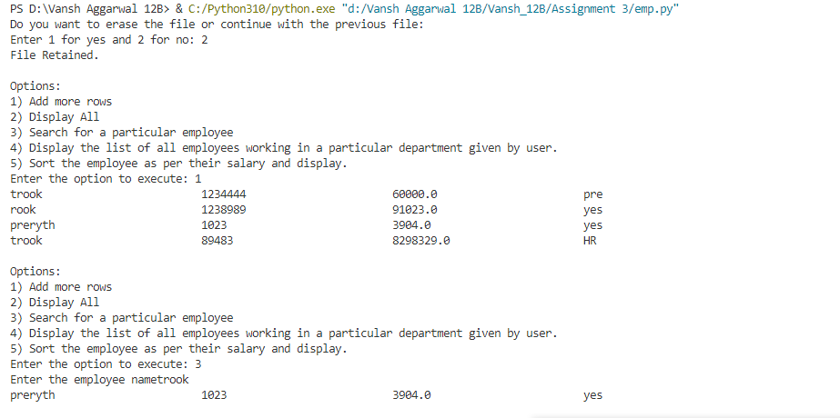
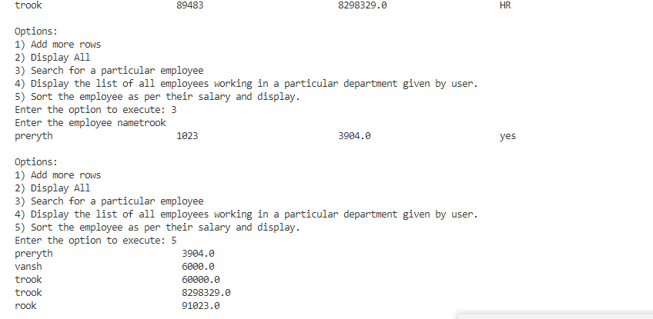

Question 4:

AIM:
To write a code that reads movie and displays the required data.

Code:
"""
Assignment 3 Question 4 done by Vansh Aggarwal
Date: 31/7/24
Time of start: 11:59

"""
import csv as c
import os

#create file

def create_file():
f = open("Travel.csv", "w")
f.close()
f = open ("Travel.csv", "a")
fout = c.writer(f)
header = ["Country", "Place", "Travel Cost", "Misc Cost"]
fout.writerow(header)
base = [["Switzerland","Lake Geveva", 145000, 18000], ["America ","Los Angeles", 125000, 25000], ["Australia","Great Barrier Reef", 20000, 12000]]
fout.writerows(base)
f.close()
print("File Created")

while True:
print ("Do you want to erase the file or continue with the previous file: ")
opt2 = int(input ("Enter 1 for yes and 2 for no: "))
if opt2 == 1:
create_file()
break
elif opt2 == 2:
print ("File Retained.")
break
else:
print ("Try again.")

# Main Code:
def add_row():
fout = open ("Travel.csv", "a+")
Country = input("Enter the Country: ")
Place = input("Enter the Place: ")
Travel_Cost = int(input("Enter the Travel Cost: "))
Misc_Cost = int(input ("Enter the Misc Cost: "))
temp = [Country, Place, Travel_Cost, Misc_Cost]
finput = c.writer(fout)
finput.writerow(temp)
fout.close()

def return_data():
fout = open ("Travel.csv", "r")
csvreader = c.reader(fout)
header = []
header = next(csvreader)
rows = []
for row in csvreader:
if row != []:
rows.append(row.append (int (row[2]+row[3])))
fout.close()
print (rows)

return (header,rows)

def delete(search_string):
header, rows = return_data()
f = open("Travel1.csv", "w")
f.close()
f = open ("Travel1.csv", "a")
fout = c.writer(f)
header = ["Country", "Place", "Travel Cost", "Misc Cost"]
fout.writerow(header)
base = [["Switzerland","Lake Geveva", "145000", "18000"], ["America ","Los Angeles", "125000", "25000"], ["Australia","Great Barrier Reef", "20000", "12000"]]
fout.writerows(base)
for i in rows:
if i[0] == search_string:
element = rows.pop(i)

fout.writerows(rows)
f.close()

os.remove("Travel.csv")
os.rename("Travel1.csv" , "Travel.csv")

# Main Loop

while True:
print ('''
The menu options are:-
1) Add more rows.
2) Display All the records and show the total cost to visit a place.
3) Delete a particular record
4) Exit
''')
opt1 = int(input("Enter the option to execute: "))

if opt1==1:
add_row()
elif opt1 ==2:
header, data = return_data()
print (f'{header[0]:30}{header[1]:30}{header[2]:30}{header[3]:30}{"Total Cost":30}')
for i in data:
print(f'{i[0]:30}{i[1]:30}{i[2]:30}{i[3]:30}{i[4]:30}')
print(i)
elif opt1 ==3:
search_string = input("Enter the Country to Delete: ")
delete(search_string)

elif opt1 == 4:
print ("Exit")
break

Sample Output:

